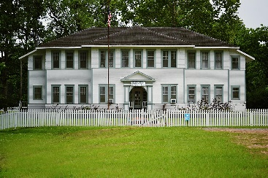

Board of Aldermen
Kenneth Kelly / Pro Tem
Kelly Stalsby
Angela Smith

OCCUPATIONAL LICENSE ORDINANCE 9-99

Ordinance 9-99 states each person pursuing and conducting any business, trade, calling, profession or vocation, within the corporate limits of the Village of Elizabeth must obtain an OCCUPATIONAL LICENSE.
Avenuinsights handles these License for the Village of Elizabeth

Please go to http://revds.com/taxpayerpdfs/CA-GA-LA-KY-TX-forms/Elizabeth/Elizabeth%20Occupational%20License%20Application.pdf to obtain the online form.

The fee schedule is at: http://revds.com/taxpayerpdfs/CA-GA-LA-KY-TX-forms/Elizabeth/Elizabeth%20Occupational%20License%20Fee%20Schedule.pdf

Sincerely,

Village of Elizabeth

Village of Elizabeth is an Equal Opportunity Employer.

