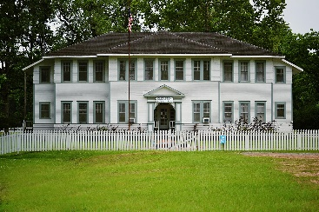

Board of Aldermen
Kenneth Kelly / Pro Tem
Kelly Stalsby
Angela Smith

For Budget Information

Please do a Public Records Request
in the Village Office
Monday – Thursday, 8am-12n, 1pm-3pm
Friday- 8am-12n

We will be glad to assist you.

Village of Elizabeth is an Equal Opportunity Employer.

